Лабораторное занятие № 16.
Графики функций
Выполнил Дацук
4 вариант
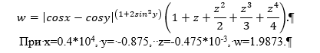
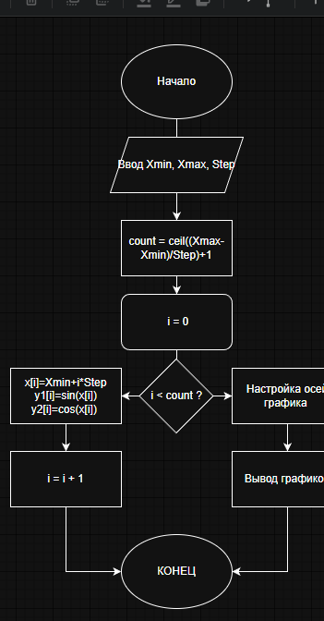
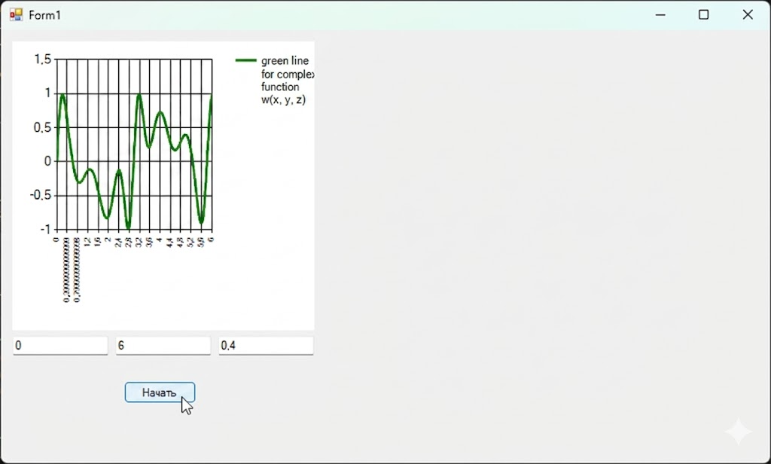
using System;
using System.Windows.Forms;
using System.Windows.Forms.DataVisualization.Charting;

namespace GraphApp
{
public partial class Form1 : Form
{
public Form1()
{
InitializeComponent();
SetupChart();
}

private void SetupChart()
{
chart1.Series.Clear();

// Создаем график sin(x)
Series sinSeries = new Series("sin(x)");
sinSeries.ChartType = SeriesChartType.Spline;
sinSeries.BorderWidth = 3;
sinSeries.Color = System.Drawing.Color.Red;

// Создаем график cos(x)
Series cosSeries = new Series("cos(x)");
cosSeries.ChartType = SeriesChartType.Spline;
cosSeries.BorderWidth = 3;
cosSeries.Color = System.Drawing.Color.Blue;

chart1.Series.Add(sinSeries);
chart1.Series.Add(cosSeries);
}

private void buttonCalc_Click(object sender, EventArgs e)
{
try
{
double Xmin = double.Parse(textBoxXmin.Text);
double Xmax = double.Parse(textBoxXmax.Text);
double Step = double.Parse(textBoxStep.Text);

int count = (int)Math.Ceiling((Xmax - Xmin) / Step) + 1;

double[] x = new double[count];
double[] y1 = new double[count];
double[] y2 = new double[count];

for (int i = 0; i < count; i++)
{
x[i] = Xmin + Step * i;
y1[i] = Math.Sin(x[i]);
y2[i] = Math.Cos(x[i]);
}

// Настройка осей
chart1.ChartAreas[0].AxisX.Minimum = Xmin;
chart1.ChartAreas[0].AxisX.Maximum = Xmax;
chart1.ChartAreas[0].AxisX.MajorGrid.Interval = Step;

// Очистка старых данных
chart1.Series[0].Points.Clear();
chart1.Series[1].Points.Clear();

// Добавление новых данных
chart1.Series[0].Points.DataBindXY(x, y1);
chart1.Series[1].Points.DataBindXY(x, y2);
}
catch
{
MessageBox.Show("Ошибка ввода данных!");
}
}
}
}

